3D MODELLING OF A VISION BASED ROBOTIC SYSTEM

**INTRODUCTION (MECHANICAL DESIGN PART)**

The vision based Robotic system has different parts. The main parts include the Robotic arm and the conveyor belt. Under the mechanical design of the project we will focus on the 3D modelling of the Robotic arm & conveyor belt, the kinematic of the robotic arm, finite analysis of the robotic arm and finally the simulation of the whole system. In this presentation we have covered the 3D Modelling then we will later cover the kinematics & finite analysis which will direct us to the material selection. Then finally simulate the system to see how it will work.

**LITERATURE REVIEW (MECHANICAL DESIGN PART)**

An autonomous robotic is a programmed mechanical arm with similar functions as a human arm. It may be the sum total of the mechanism or may be part of a more complex robot (Patil et al., 2009).

Eye-bot is a typical model used to pick and place the desired colour objects from one location to another. This robot is used in sorting the objects in a mixture of different colour objects. The following components make up a typical object sorting robotic arm:

Links and joints (Under mechanical design)

Actuators (Under electrical design)

Controller (Under the software design)

End-effector (Under mechanical design)

Sensor (Under electronics design)

1. **Links and joints**

In a robot, the connection of different manipulator joints is known as Robot Links, and the integration of two or more links is called as Robot Joints. A robot link will be in the form of solid material and it can be classified into two key types: input link and output link. The movement of the input link allows the output link to move at various motions. An input link will be located nearer. Robot Joint is the important element in a robot. It helps links to travel in different kind of movements. There are five major types of joints:

* Rotational joint
* Linear joint
* Twisting joint
* Orthogonal joint
* Revolving joint

1. **End-effector**

In robotics, an end-effector is the device at the end of a robotic arm, designed to interact with the environment. The exact nature of this device depends on the application of the robot. In the strict definition, which originates from serial robotic manipulators, the end effector means the last link (or end) of the robot. At this endpoint, the tools are attached. In a wider sense, an end effector can be seen as the part of a robot that interacts with the work environment. This does not refer to the wheels of a mobile robot or the feet of a humanoid robot which are also not end-effectors—they are part of the robot's mobility. The major types of robot end-effectors are:

* Grippers - Grippers are the most common type of end-effectors. They can use different gripping methods (such as vacuum or use of fingers).
* Material removal tools - These include cutting, drilling and deburring tools installed as robot tools.
* Welding torches - Welding is a very popular robotic application. Welding torches have thus become very efficient end-effectors that can be controlled in a sophisticated way for optimized welding.
* Tool changers - Tool changers are used when many different end effectors need to be used in sequence by one robot. They are used to standardize the interface between the robot flange and the base of the tool. They can be manual or automatic.

**METHODOLOGY (MECHANICAL DESIGN PART)**

**IMPLEMENTATION BLOCK DIAGRAM**

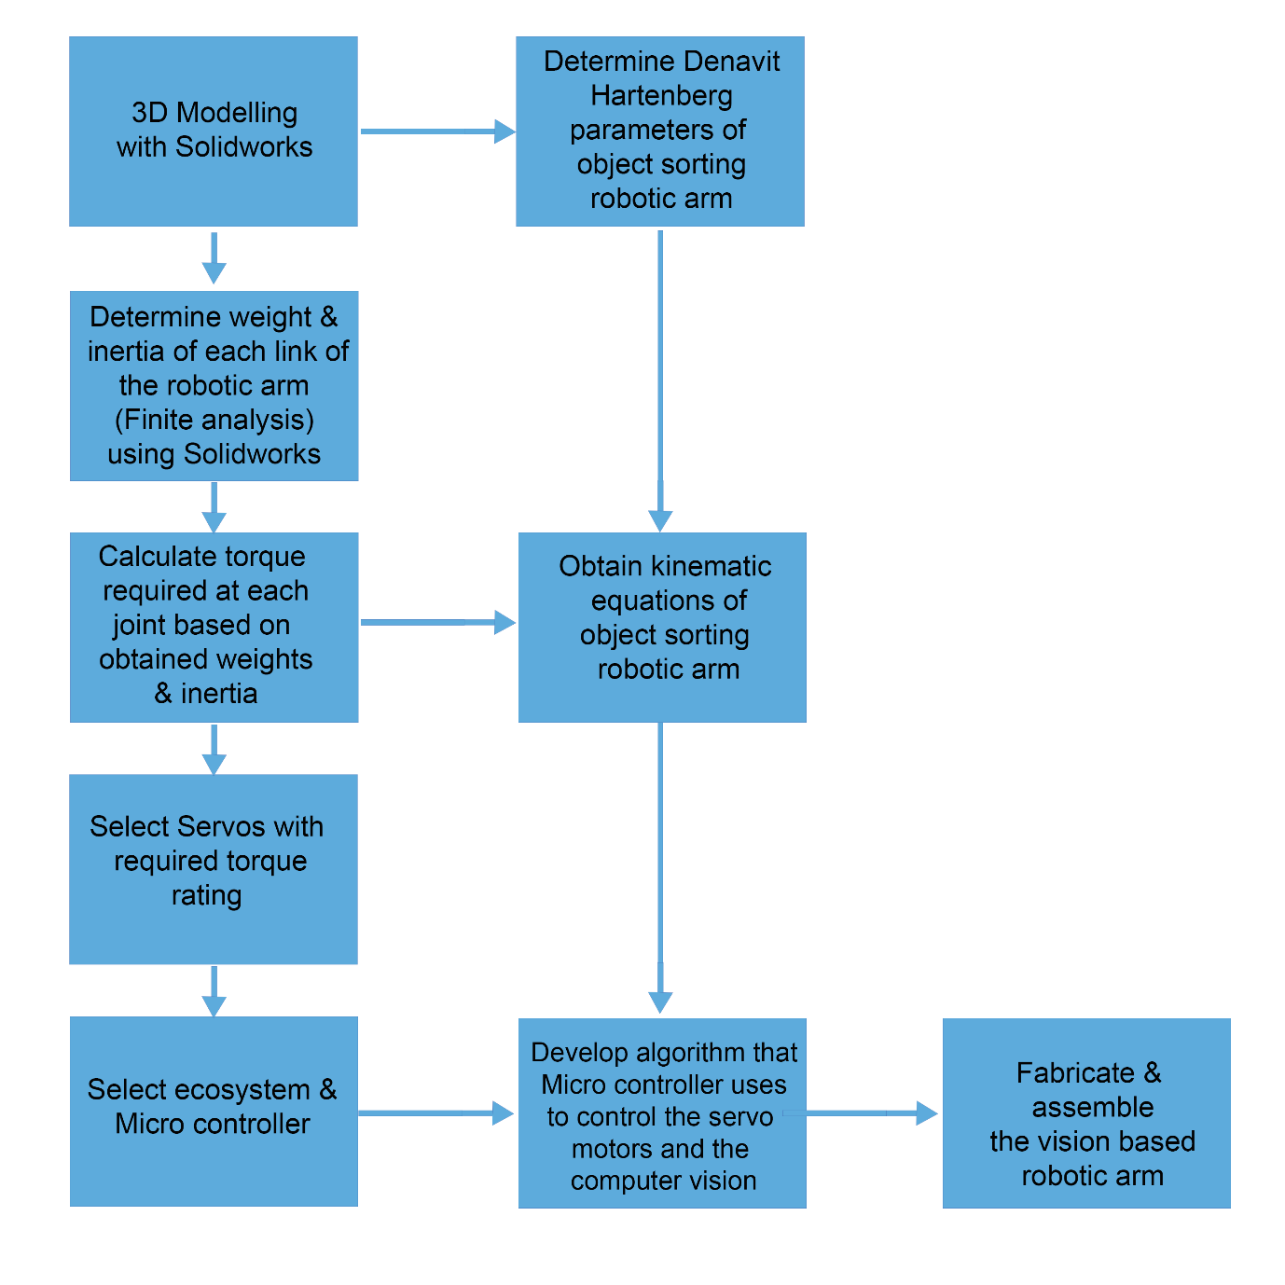

*Figure 1 Implementation block diagram, Source designed from Photoshop*

1. **3D MODELLING with Solidworks.**

Computer modelling is of great importance because it aids better understanding of a particular system and communicate ideas behind the system clearly. It helps visualize a system as it is, permits the specification of the structure and behaviour of a system, and serves as template that direct the construction of system’s prototype. Computer modelling also helps document decisions. The robotic arm has five degrees of freedom. A CAD model of the arm was designed with Solidworks. The modelling was sectioned into part modelling, assembly modelling and annotated drawing. During part modelling, all the components of the arm (the links, base, end-effector, turn table, actuators, colour sensor, controllers and joints) were designed separately. Then, the components were then imported to assembling workspace where coupling operation was performed. The output of assembly section was a full scale model of the arm. The model is shown in figures below

1. Robotic arm

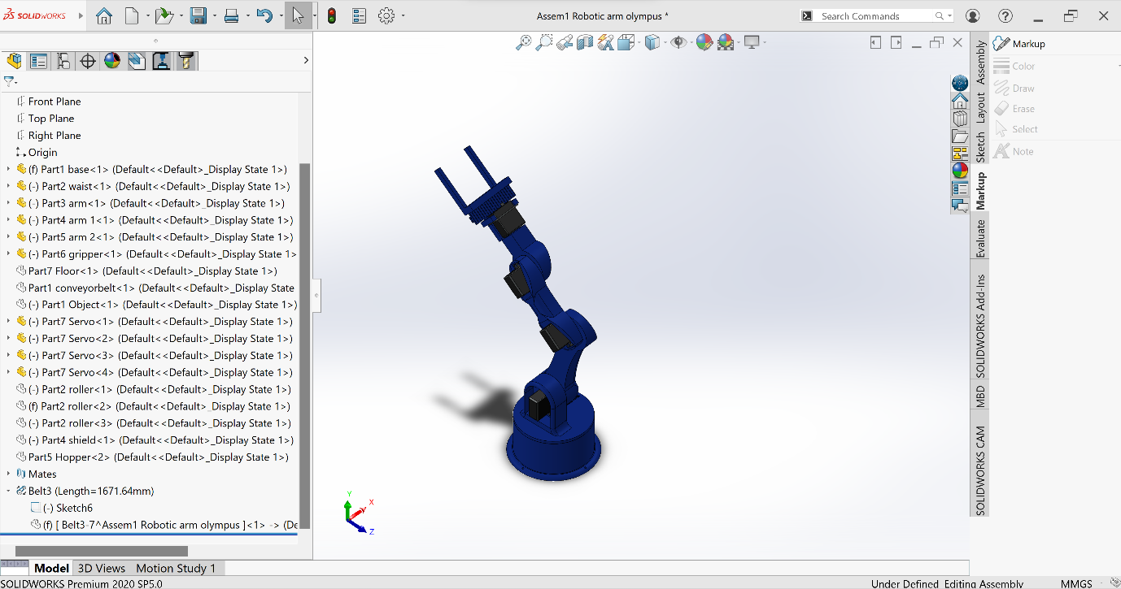

*Figure 2 Robotic arm, Source designed from solidworks*

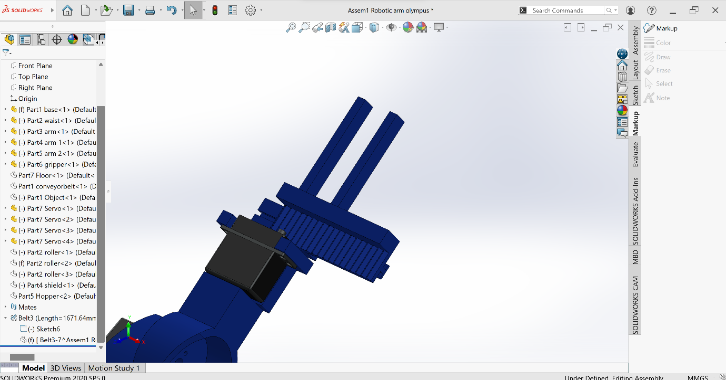

*Figure 3 End effector-Gripper, Source designed from solidworks*

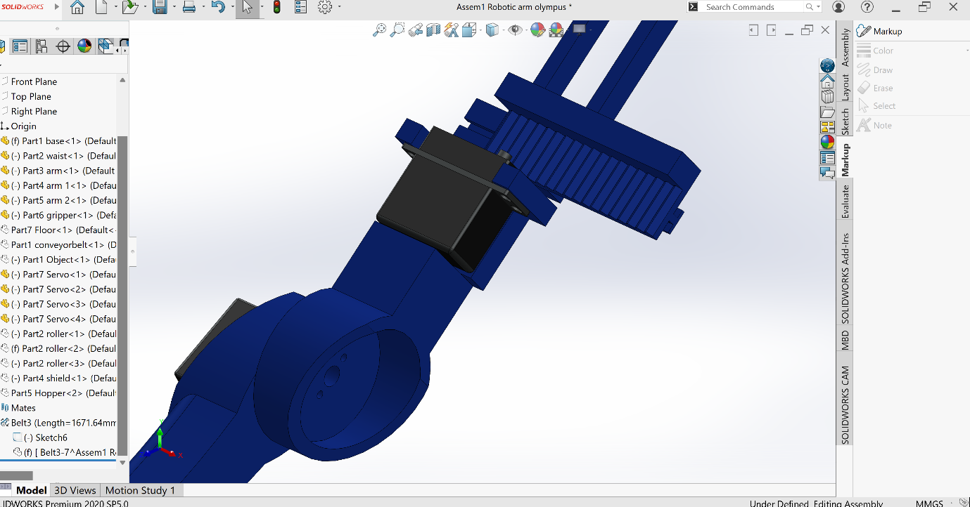

*Figure 4 Wrist, Source designed from solidworks*

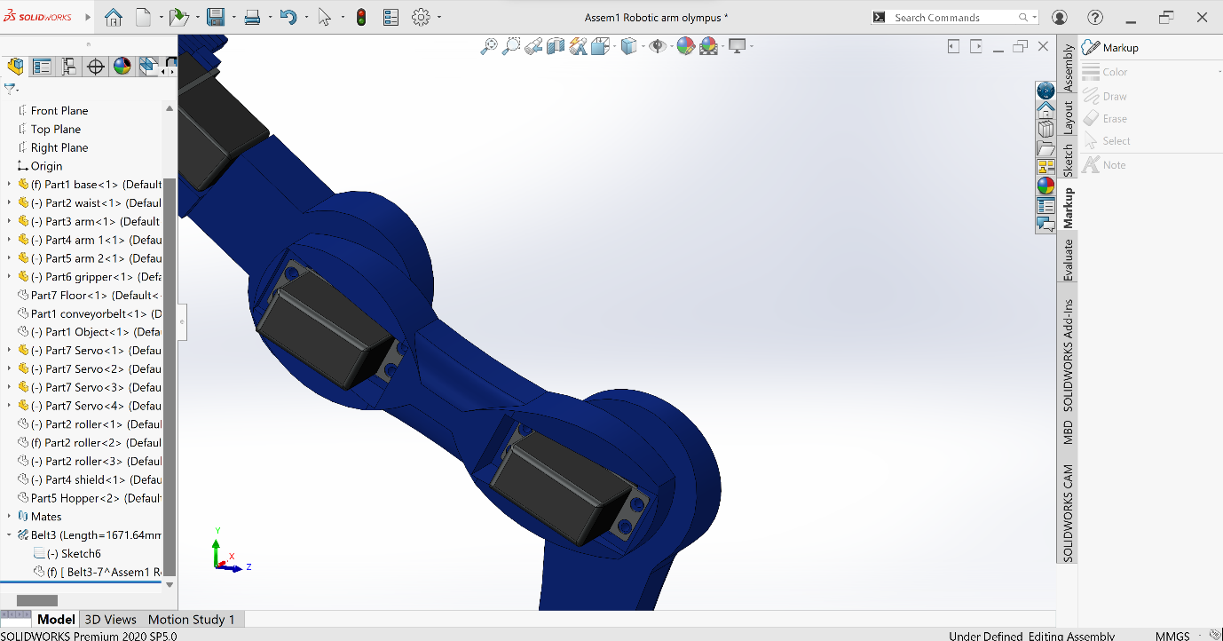

*Figure 5 Elbow, Source designed from solidworks*

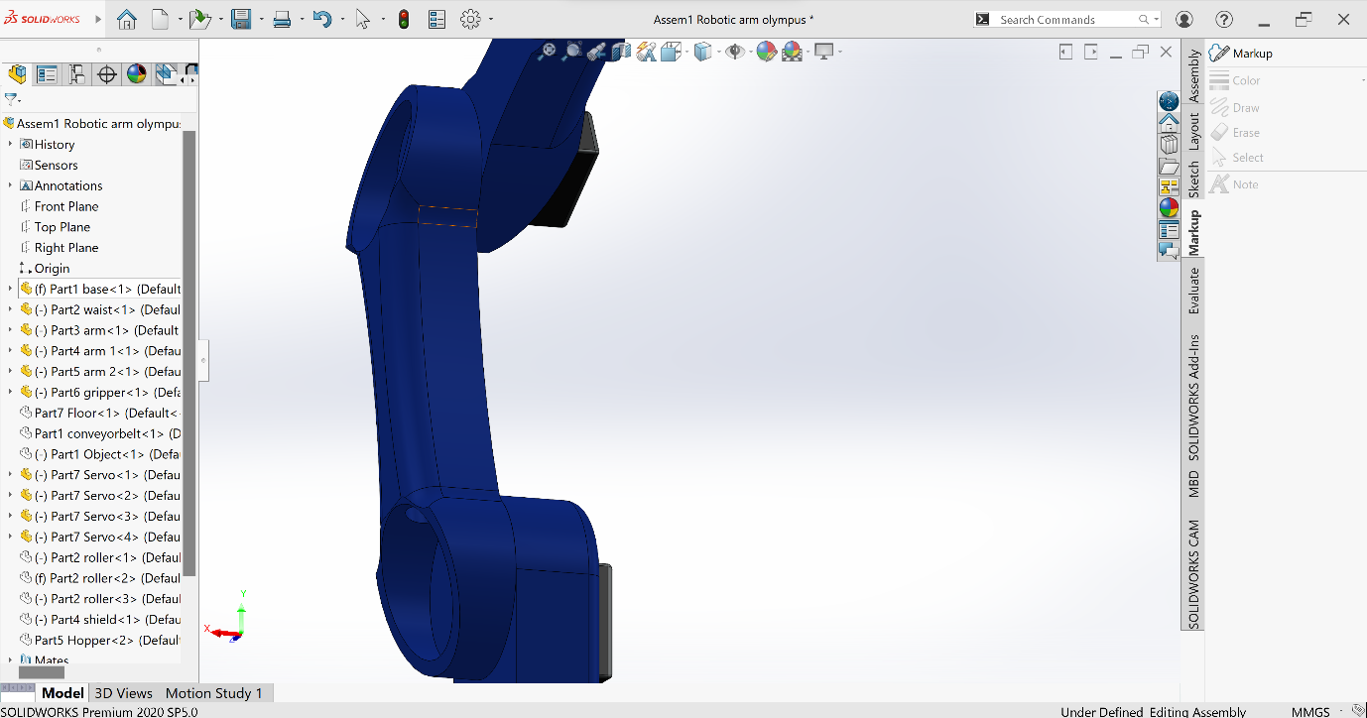*Figure 6 Shoulder, Source designed from solidworks*

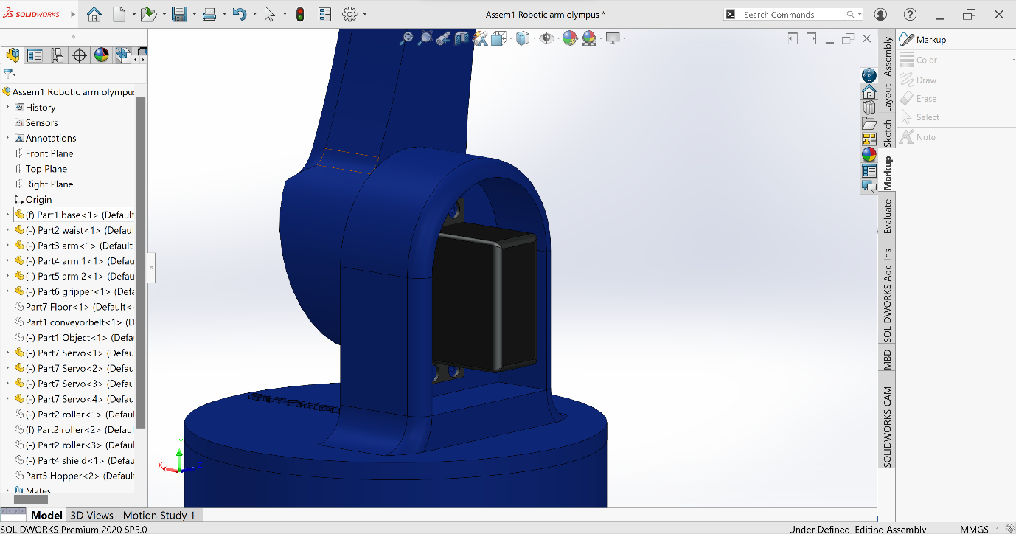

*Figure 7 Base, Source designed from solidworks*

1. Conveyor belt

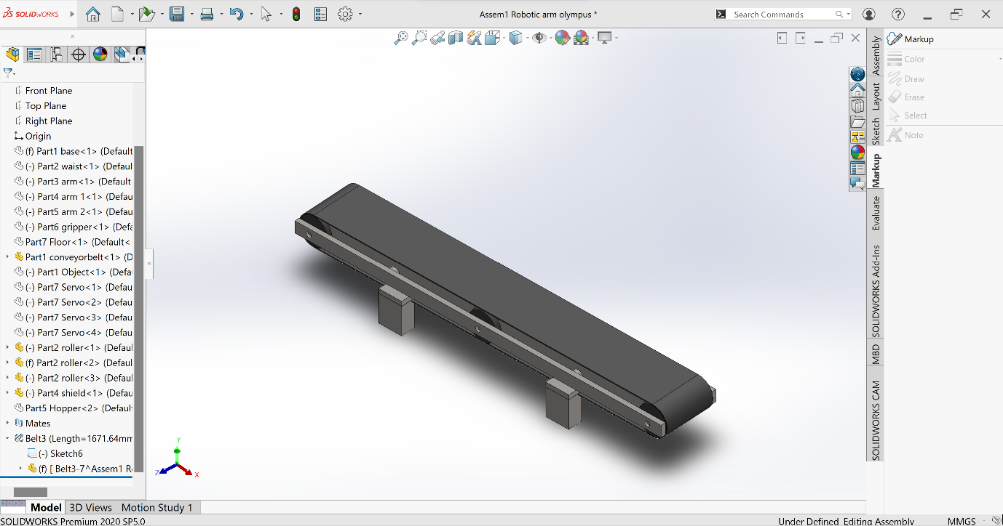

*Figure 8 Conveyor belt, Source designed from solidworks*

1. **Vision based robotic system**

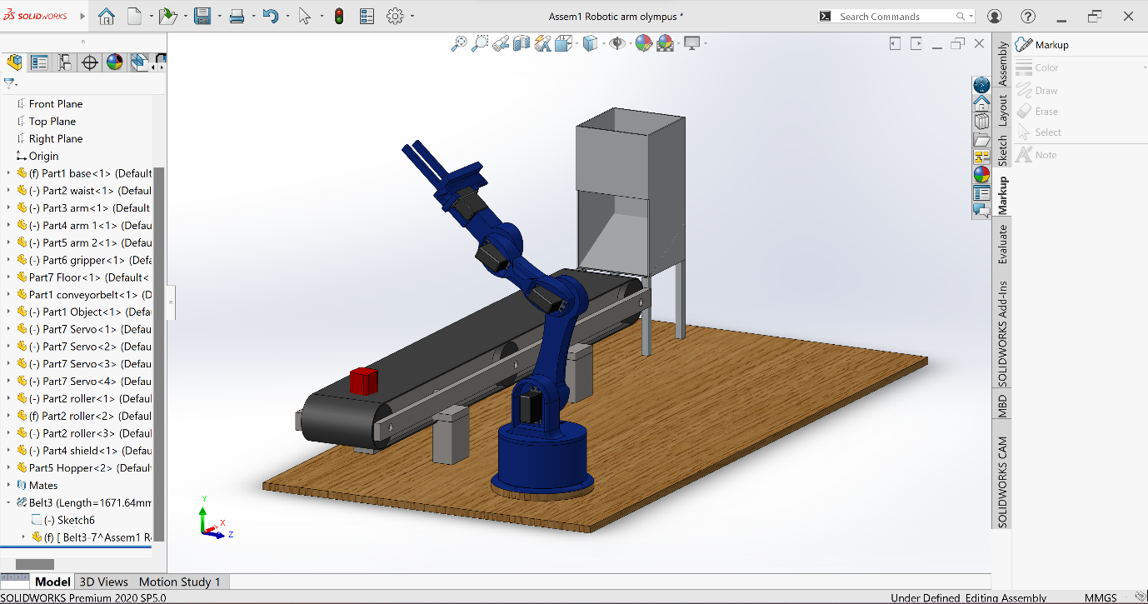

*Figure 9 Vision based robotic system, Source designed from solidworks*

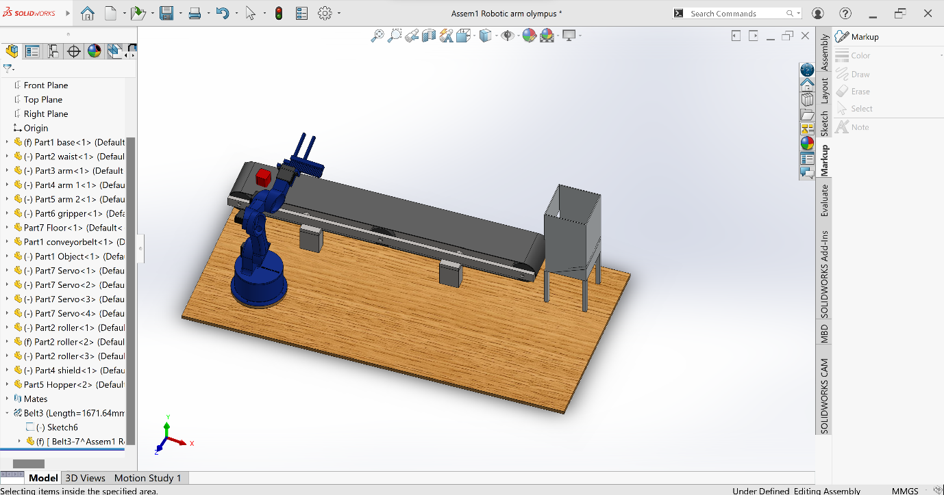

Reference

Patil, C., Sachan, S., Singh, R. K., Ranjan, K., & Kumar, V. (2009). Self and Mutual Learning in Robotic Arm, based on Cognitive systems. West Bengal: Indian Institute of Technology Kharagpur.